STAFF NEWS

New Partner Dr Pickering

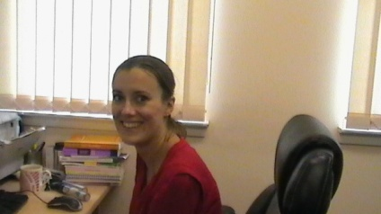

We are delighted to announce that Dr Anna Pickering will be joining us as a partner on 1st October 2014. Dr Pickering has been training with us over the past 3 years and qualified as a GP in August. We all wish Dr Pickering a long and happy career here. We would also like to thank Dr Davidson for all her help while she has been working over the past 12 months as a locum. Dr Davidson will leave us on 30th September.

Dr Affleck

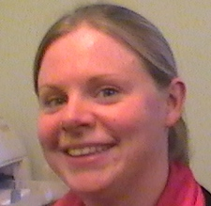

Dr Rachel Affleck has returned to the practice to complete her final year of training.

Patricia Orr
Patricia Orr, our long serving receptionist retired from the Health Centre on 31st July 2014. We would like

to thank Patricia for her loyalty, hard work and commitment over the last 20 years. We wish her a very long and happy retirement

Shona Currie
We are pleased to welcome Shona Currie as a new member of our reception team. Shona joined us in August 2014.

Walk In Flu Clinics
Our Walk-In Flu Clinics are 9.00am to 1.00pm Tuesday 30th September and 2.00pm to 6.00pm Monday 6th October

Pre- School Children Flu
All preschool children aged 2 and above will be offered the nasal form of flu vaccination at our Walk In Flu Clinic on the afternoon of 6th October 2014 at the Health Centre.

Primary School Children Flu
All children attending Primary Schools in the area will also be offered the vaccination. This will take place in the school premises again from October 2014.

Shingles
From 1st September 2014 all patients aged 70 (on 1st September 2014)will be offered immunisation against herpes zoster. In addition to this patients aged 78 and 79 years ( as on 1st September 2014) will be offered the same vaccination as part of a catch up campaign.

Meningitis C
If you are aged under 25, attending University for the first time and have not been vaccinated against Men C since you were 10 year old you are entitled to this vaccination. Please contact the surgery.

WHO NEEDS THE FLU VACCINATION?
Anyone who suffers from heart or lung problems, who has certain long term medical conditions, or is 65 or over, should get the flu vaccine.
If you have an underlying medical condition, flu can hit you hardest. The jab is the safest and most effective way of protecting yourself.
Conditions and diseases which can make flu much more dangerous include:
- asthma
- bronchitis
- emphysema
- cystic fibrosis
- chronic heart disease
- chronic kidney failure
- multiple sclerosis
- liver problems (such as cirrhosis/hepatitis)
- diabetes
- HIV infection.
Anyone undergoing chemotherapy or radiotherapy treatment should also get immunised. We will advise you on the most appropriate time for the flu vaccine to be given
including young carers are also eligible for the flu vaccine. In addition anyone who is pregnant.
Contact the surgery to arrange an appointment from Late September. The flu jab is free to everyone in Scotland with an underlying medical condition or who is 65 or over.
Remember, the vaccine only takes a few minutes and could help keep you well over the winter.
If you are over 65 you are also eligible for a pneumococcal vaccine. This is a one off immunisation that can be given at the same time as the flu vaccine.
PRESCRIBING REVIEWS
The Practice is constantly reacting to prescribing updates.
Changes have been introduced recently to the inhalers used to treat COPD. Patients with COPD are called in for a routine annual check and their medicines will be reviewed at this time.
Recent research has shown that Omeprazole and Lansoprazole can have side-effects when taken long term. The Practice will be reviewing all patients taking these medicines to ensure that they are on the smallest effective dose

Killearn Pharmacy Managed Prescription Service
Killearn Pharmacy now offer a complete managed prescription service. This means that on a regular basis the pharmacy will order your prescriptions in advance on your behalf, dispense the medications and have them ready for collection at your convenience.

Bowel Screening
Bowel Cancer is Scotland’s third most common cancer. If you are aged 50-74 you will receive a bowel screening kit- we encourage all patients to undertake the test. Early detection makes the cancer much more treatable- If you have misplaced your kit please call 0800 0121 833 to request a replacement

